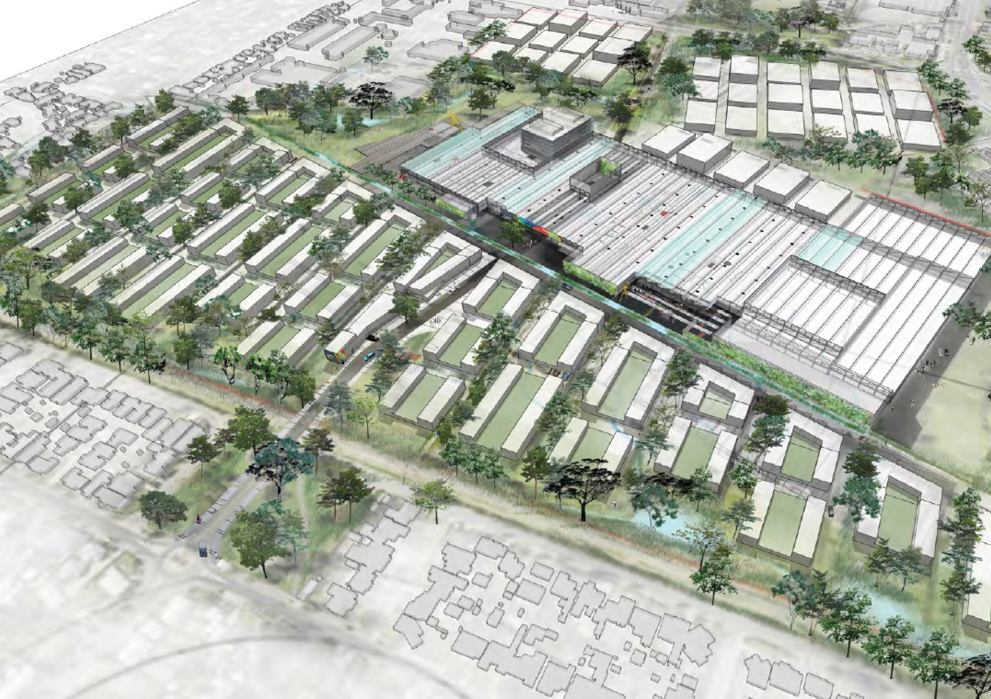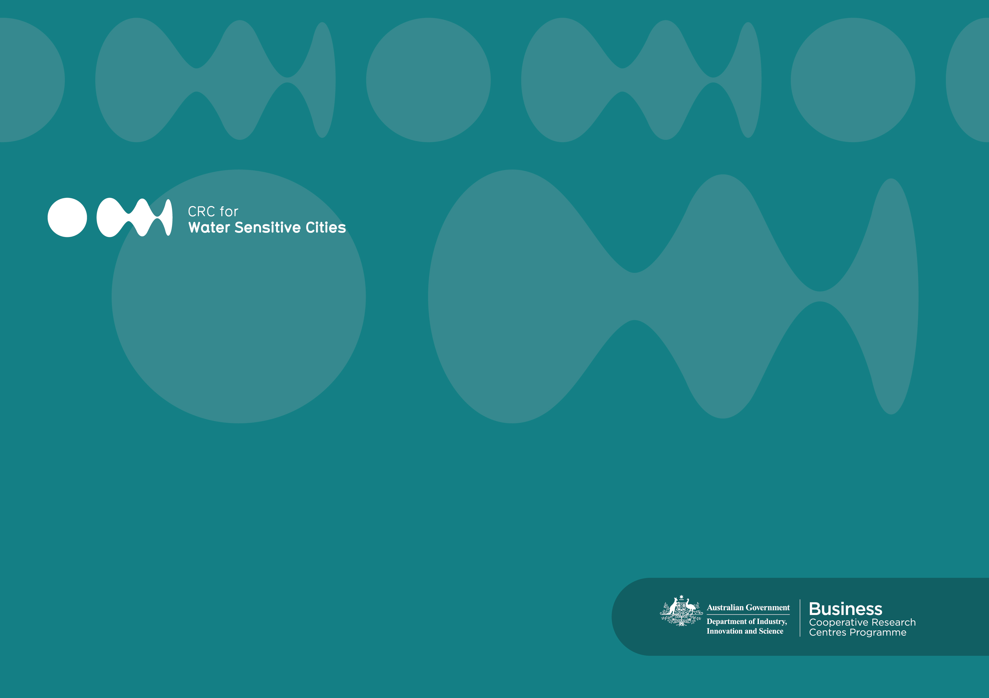­­

Document Title

Document subtitle

**Document Title**  
Document Subtitle

**Authors**  
John Smith

© 2015 Cooperative Research Centre for Water Sensitive Cities

ISBN 9xx-x-xxxxxxx-xx-x

This work is copyright. Apart from any use permitted under the Copyright Act 1968, no part of it may be reproduced by any process without written permission from the publisher. Requests and inquiries concerning reproduction rights should be directed to the publisher.

**Publisher**

Cooperative Research Centre for Water Sensitive Cities

Level 1, 8 Scenic Blvd, Clayton Campus

Monash University

Clayton, VIC 3800

**p.**+61 3 9902 4985  
**e.** admin@crcwsc.org.au  
**w.** www.watersensitivecities.org.au

**Date of publication:** January 2014

**An appropriate citation for this document is:**

xx-Author-xx (xx-Year-xx) xx-PublicationTitle-xx   
Melbourne, Australia: Cooperative Research Centre for Water Sensitive Cities,

ISBN 9xx-x-xxxxxxx-xx-x, xxMonthxx xxYearxx.

Table of Contents

Executive Summary 4

Introduction 6

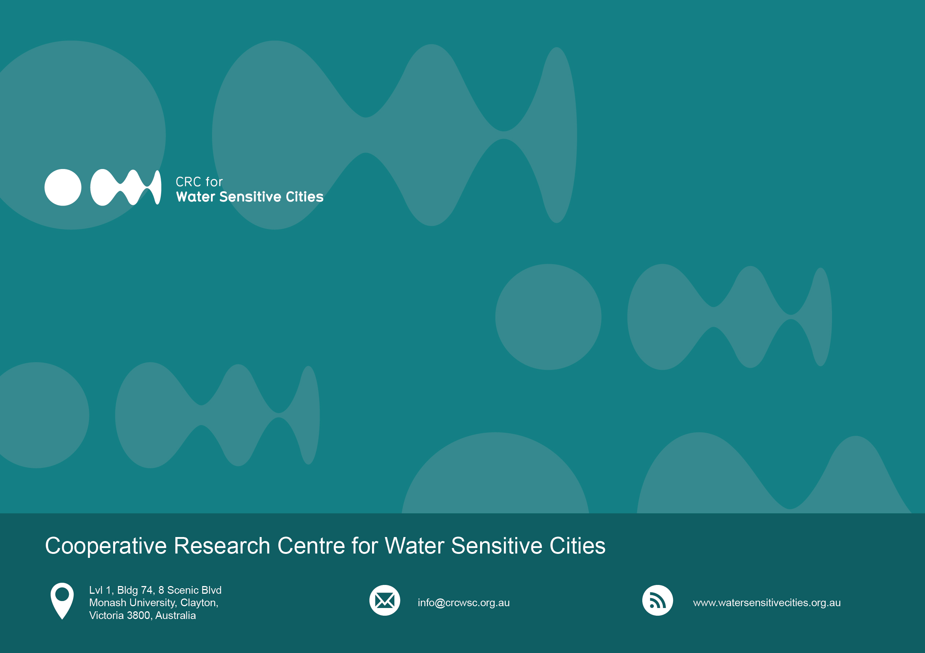Heading 1

Heading 2

Heading 3

Pitchfork plaid shabby chic, Etsy squid put a bird on it vinyl Tumblr Portland jean shorts. Normcore Pitchfork Blue Bottle quinoa, 90's direct trade aesthetic. Cred Echo Park four loko scenester, 90's fap squid artisan pork belly mixtape direct trade street art small batch Pitchfork. Locavore lomo normcore four dollar toast, meh deep v keytar chillwave meggings retro gentrify cliche Carles. Viral Portland photo booth kitsch. Keffiyeh sustainable taxidermy, selfies cardigan Shoreditch iPhone scenester flannel actually irony. Tofu cold-pressed roof party Godard raw denim actually, lo-fi DIY 90's hoodie viral Truffaut brunch.

Sriracha selvage umami, 90's vegan letterpress actually Thundercats four loko trust fund cardigan. Shabby chic disrupt farm-to-table bespoke vegan. Cold-pressed kogi dreamcatcher fashion axe irony. Godard distillery keffiyeh, Banksy wayfarers letterpress you probably haven't heard of them flexitarian scenester banjo tousled direct trade put a bird on it sriracha Shoreditch. Shoreditch actually letterpress semiotics, leggings keffiyeh crucifix. Whatever cred chillwave, scenester single-origin coffee put a bird on it Intelligentsia cray cornhole Helvetica selfies tousled sustainable. Put a bird on it Carles flannel meh, readymade master flexitarian hashtag quinoa YOLO.

This project has two central aims, which are to:

1. Provide future rainfall projections at appropriate space and time scales to support design decisions in the overall Centre for Water Sensitive Cities project.
2. Provide quantitative estimates of the uncertainties in such projections in a way usable by these project components.

This project has two central aims, which are to:

* Provide future rainfall projections at appropriate space and time scales to support design decisions in the overall Centre for Water Sensitive Cities project.
* Provide quantitative estimates of the uncertainties in such projections in a way usable by these project components.

