case study title here (15 words max)

Author One ¹, Author Two ², Author Three ²
1. Organisation, Melbourne, VIC, Australia
2. Another Organisation, Sydney, NSW, Australia

The header consists of 10 lines with 14 point spacing.

The last line below should be left blank.

Keywords
Please list a minimum of three (3) keywords

CASE STUDY TIME FRAME
20__ to 20__

CASE STUDY BUDGET

CASE STUDY SUMMARY
Maximum of 100 words outlining the objectives of the activity, key actions and outcomes

CASE STUDY DETAIL
Maximum of 700 words providing an overview of the activity addressing the points below.
- The specific issue being addressed.
- Approach developed to address this issue.
- Summary of activities and their implementation.
- Summary of outcomes and measurable impacts of the activities.
- The extent to which the outcomes are sustainable and were achieved in a cost efficient manner.
- Important lessons learnt and critical success factors.
- Other comment/information

It is important this template is adhered to as all case studies accepted for presentation at 4th WSCC will be printed as submitted.

SUBMISSION INSTRUCTIONS (Delete this section when submitting your final case study)
Page Limit
Maximum 2 pages of text followed by a maximum of 3 pages of supporting tables and graphics.

Page Size and Layout
The paper should be prepared for A4 size paper (210 x 297mm), with overall margins of 20mm on all sides of the paper (top, bottom, right and left). Use font type Arial for the entire document. Justify text.
Do not include page numbers, headers or footnotes.

Heading
The top section of the first page of the paper should contain the paper title, author list, and affiliations. This section must consist of 10 lines (whether filled or blank).

Titles must be in 12-point font, bold and capitalised. Do not use more than two lines for the title, and try to limit the title to ten words.

Authors and affiliations must be in 10-point font. Authors with more than one affiliation should indicate additional affiliations by numbers, superscripted following the author’s name.

Affiliations must be entered as follows: Organisation, City/ Town, State (abbreviated), Country
(e.g. Australian Water Association, Sydney, NSW, Australia)

References
Do not include references or acknowledgements in this abstract. If the abstract is accepted for presentation, references can be included in the final paper.

Figures and Tables
Figures and tables, both of which must have numbers and captions, can be included in a maximum of 3 pages at the end of the submission. Colour images are welcome. Refer to page 3 for examples.

Equations
Mathematical equations should be created using equation editor in Word. Equations should be centred between left and right margins and be separated by a blank line. All equations should be sequentially numbered using numbers in parentheses along the right margin.

Submission Instructions
- Maximum 2 pages of text followed by a maximum of 3 pages of supporting tables and graphics.
- Ensure you run a spell-check and ask a peer to proof your abstract prior to submitting.
- Convert this document to PDF format before submitting.
- Files larger than 10MB should be compressed as they are too large to upload.
- Email your case study to 4wscc@crcwsc.com.au
- If your case study does not meet the submission requirements, it will not be processed for review.

Figure 1 is an example of a graph in the text with a caption below the figure. Please include a blank line above the figure and below the caption. The caption should be in italics.

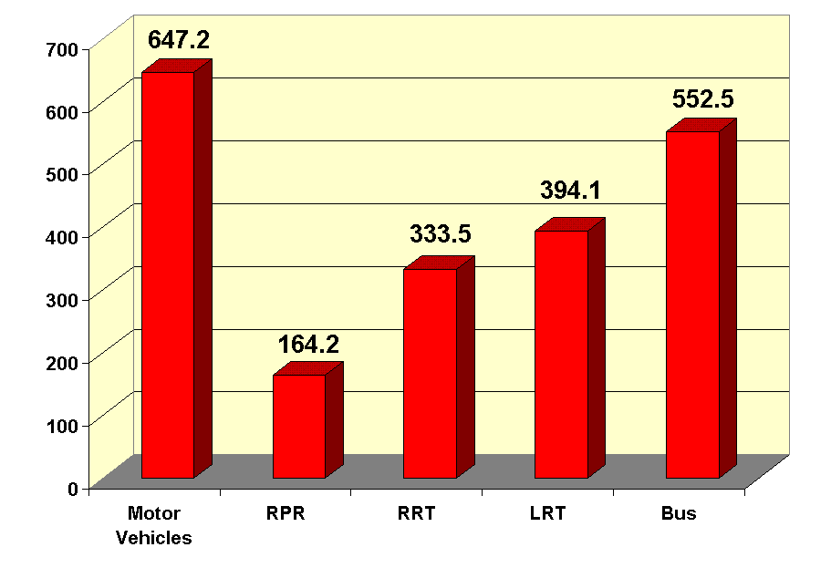
Figure 1: Example of a Figure

Table 1 shows an example of a table, where the caption should be on the top of the table.

Table 1: Example of a Table
Heading 1 | Heading 2 | Heading 3
Entry 1 | Entry 2 | Entry 3

Figure 2 is an example of an oversized figure.

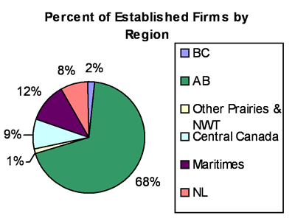

Figure 2: Example of an Oversized Figure

