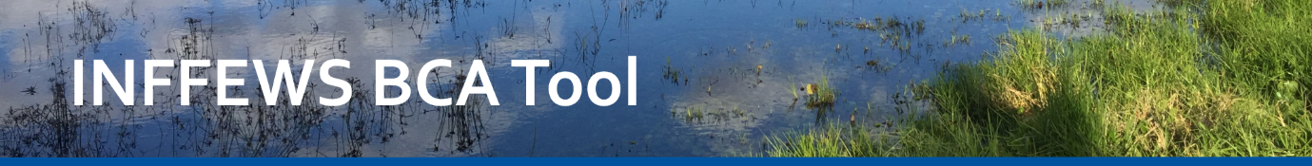
Rough BCA Tool Template | 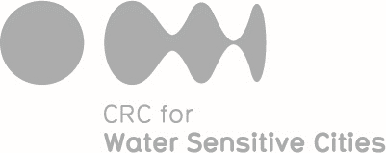

1. Name of project:
2. Brief description of location and scale
3. General goal for the project
4. Activities and actions of the project
5. Describe the “with project” scenario. In broad terms, how will the outcomes evolve over time in the presence of the project? What difference will the project make as a result of the activities and actions listed in question 4?
6. Describe the “without project” scenario (baseline or business as usual). In broad terms, how will the outcomes evolve over time in the absence of the project? This should reflect that, even without the project, things may change. They may worsen or they may improve, but we need to anticipate what they would do without the project, so that we can use this as the baseline for assessing the benefits of the project.
7. Describe the benefits, costs and negative spinoffs of the project. Indicate their nature, scale, duration, and who they accrue to. Either include benefits, costs and spin-offs for the whole community, or for the project organisation alone, depending on the needs of the organisation. See the Appendix for checklists to help you identify benefits, costs and spin-offs.
Benefits. Should be improvements in the with project scenario relative to the without project scenario.
Costs. May include upfront project costs, maintenance costs, and compliance costs (if the project or policy involves a regulatory element). Include cash and in-kind costs.
Negative spin-offs. Adverse impacts of the project on other outcomes or other projects or other groups, not necessarily related to water sensitive cities.

8. Score the project benefits (B):  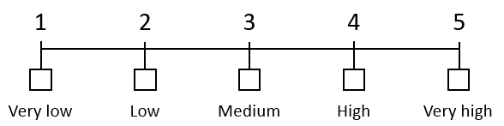 | Score B (1 to 5) = _______.  Consider the scale of benefits (e.g. area or people), importance of the beneficial outcomes, duration of benefits, potential adverse impacts. Benefits must be based on the differences between with and without project scenarios. Factor in any negative spin-offs as negative benefits.
9. Score the project costs (C): | Score C (1 to 5) = _______.  Consider upfront project costs, maintenance costs, compliance costs (if the project or policy involves a regulatory element) and disposal/restoration costs.
10. Score the project risks (R): | Score R (1 to 5) = _______.  This is the likelihood that the project will fail to deliver its intended benefits. Consider technical, socio-political, financial and management risks.

11. Time lag (L) from now until the main benefits of the project would be delivered. May include lags involved in project implementation, human behaviour change, plant growth, water movement, or environmental changes. L (in years) = _______. (e.g. 15)
Identify the appropriate real discount rate (D) to convert future values to present values. Information about standard discount rates in different Australian states and nationally is provided in the INFFEWS BCA Tool Guidelines. D = ________. (e.g. 0.07)
12. Calculate the Rough Benefit: Cost Ratio for the project. The Rough BCA Tool spreadsheet can be used for this purpose.
Rough BCR = B*(1.5 – R/5)/C/(1+D)^{L}.
A score of at least 1 for the Rough BCR would be viewed as a very positive initial indication about the project, while a score below 0.5 is discouraging.

Appendix. Checklists of benefits, costs and spin-offs
 | Benefits
1 | Reduced water consumption
2 | Reduced or delayed investment in infrastructure (e.g. water treatment plant)
3 | Reduced recurring costs (e.g. energy for cooling)
4 | Improved management of wastewater
5 | Increased business profits (e.g. from sewer mining)
6 | Increased work productivity (e.g. from less extreme heat)
7 | Increased tourism
8 | Improved aesthetics
9 | Improved opportunities for recreation
10 | Reduced crime, increased community cohesion
11 | Reduced mortality (e.g. from reduced extreme heat)
12 | Reduced morbidity, improved health (e.g. from reduced extreme heat)
13 | Reduced greenhouse gas emissions, increased CO₂ sequestration
14 | Groundwater recharge (e.g. for potable extraction or wetland enhancement)
15 | Ecological improvement, biodiversity
16 | Improved air quality
17 | Enhancing water quality in a water body
18 | Reduced flood risk
19 | Reduced risk of poor water quality due to fire
20 | Improved security of water supply

 | Cost
1 | Project costs  Physical materials: pipes, pumps, concrete, bricks, slabs, ...  Machinery and equipment  The time of people employed to implement the project or provide support to the project  Cars (purchase or depreciation or hire, fuel, repairs, servicing, etc., or capture all that with a per kilometre cost such as the standard rates specified by the Australian Tax Office)  Office space and other office costs (telephones, printers, computers, internet, ...)  Insurance  Publicity and communications  Design and printing  Costs of obtaining required permits and permissions  Legal costs  Payments to people to encourage behaviour change  Costs of research, data collection, analysis, etc. undertaken as part of the project  In-kind costs, for items such as project staff salaries, administrative support, office space, stationary, and telephone calls
2 | Maintenance costs  Maintain, repair, or replace equipment or structures  Pay the wages of people responsible for ongoing education, training, awareness raising, or ongoing project management  Continuing payments to people to ensure ongoing adoption of improved practices  Inspecting and enforcing compliance  Monitoring, analysing and reporting outcomes from the project
3 | Compliance costs  Loss of profits such as through changing land use from commercial to non-commercial purposes  Additional expenses to implement works and actions  Legal and administrative costs required for compliance
4 | Disposal or restoration costs  Costs involved in removal of structures, disposal of materials or restoration of the site at the end of the project
5 | Excess burden of taxation  The 'deadweight loss' from efficiency costs and admin costs involved in collecting and dispersing money through the tax system. The information you need to provide are (a) the proportion of costs that are collected through the tax system, and (b) the marginal excess burden (a proportion) for each taxed dollar.

 | Negative spin-off
1 | Would any of the items in the Benefits checklist be made worse as a result of the project?
2 | Would any other outcome (not related to water sensitive cities) be made worse as a result of the project?
3 | Would the project result in increased costs or risks for some other project or program, or for other groups or organisations, that might not be thought of if the focus is only on water sensitive cities?

