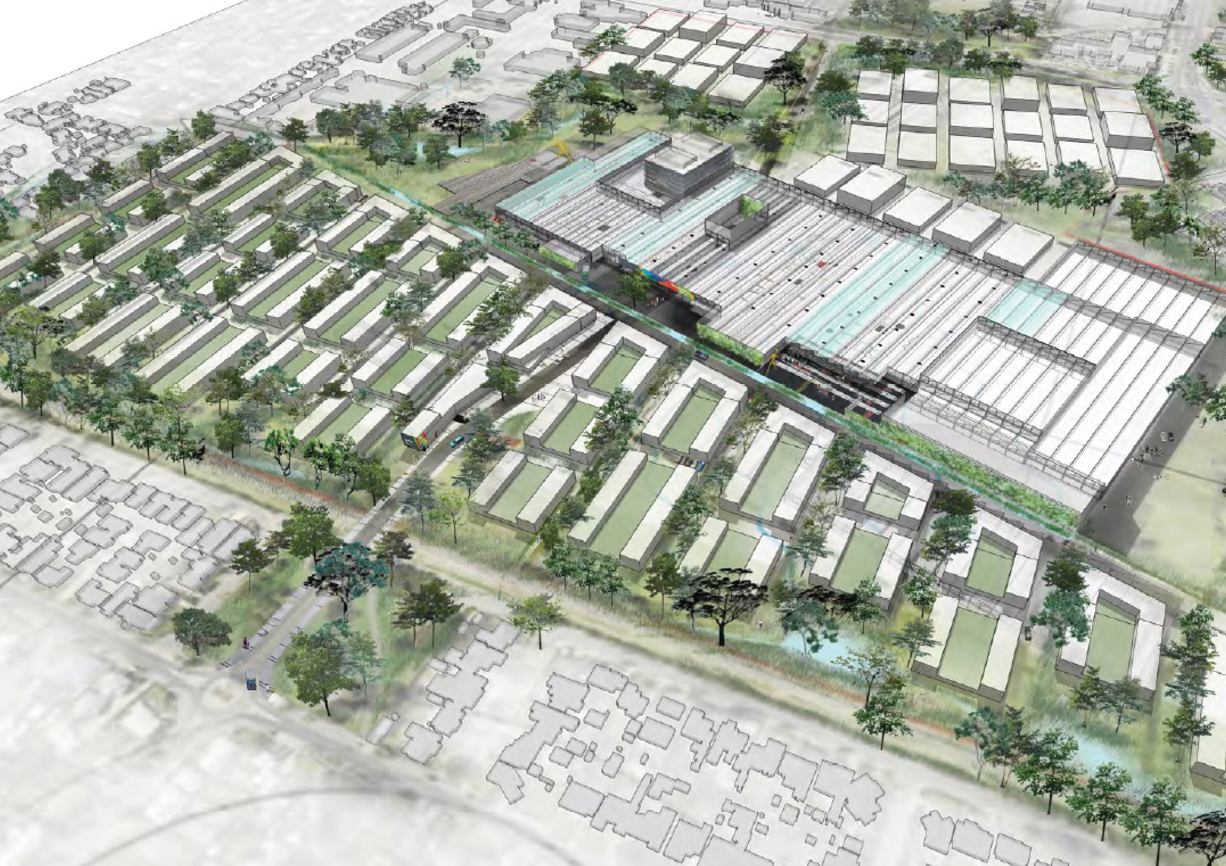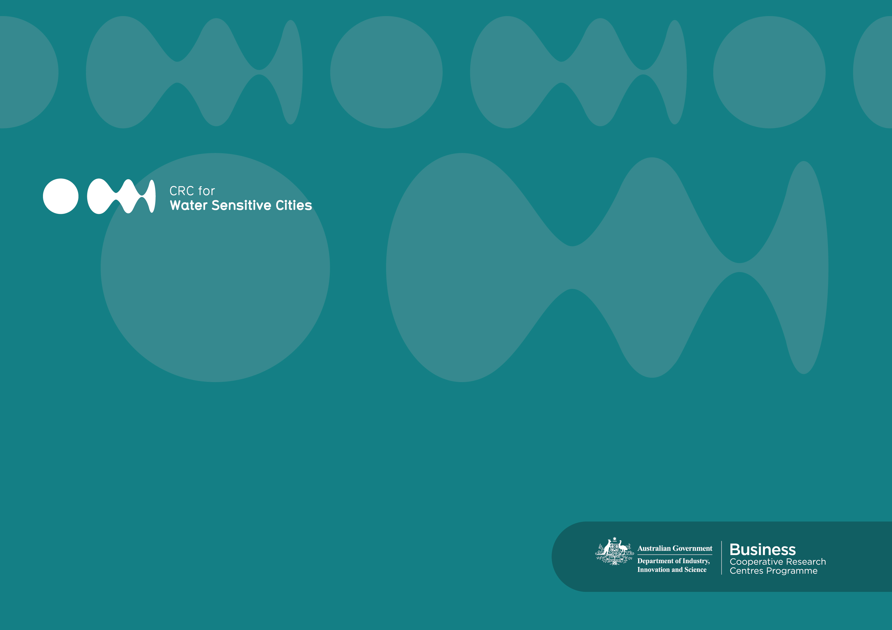­­

Water Sensitive Cities Benchmarking and Assessment

Place name, Country



**Document Title**   
Water Sensitive Cities Benchmarking and Assessment: Insert place name

**Authors**  
Insert author names

© 2024 Water Sensitive Cities Australia

This work is copyright. Apart from any use permitted under the Copyright Act 1968, no part of it may be reproduced by any process without written permission from the publisher. Requests and inquiries concerning reproduction rights should be directed to the publisher.

**Publisher**

Water Sensitive Cities Australia

8 Scenic Blvd, Clayton Campus

Monash University

Clayton, VIC 3800

**e.** info@wscaustralia.org.au  
**w.** www.watersensitivecities.org.au

**Date of publication:** Insert month and year

**An appropriate citation for this document is:**

Authors (Year). Water Sensitive Cities Benchmarking and Assessment: Place name.  
Melbourne, Australia: Water Sensitive Cities Australia, insert partner organisation details.

**Disclaimer**

The authors are accredited by Water Sensitive Cities Australia to use the Water Sensitive Cities Index, including facilitating workshops and preparing benchmarking and assessment reports. Water Sensitive Cities Australia makes no warranty with regard to the accuracy of information the authors create using the Water Sensitive Cities Index. Water Sensitive Cities Australia will not be liable if the information is inaccurate, incomplete or out of date, nor be liable for any direct or indirect damages arising from its use.

Table of Contents

Table of Contents 3

Executive Summary 4

1. Introduction 6

2. WSC Index Tool 7

2.1. Rating Process 9

2.2. Interpreting WSC Index Scores 9

3. Evaluating Performance 11

3.1. City–State Benchmarking 11

3.2. Water Sensitive Goals 12

4. A X-Point Plan 17

4.1. Enabling Structures 17

4.2. On-ground Practices 17

4.3. Socio-Political Capital 17

Appendix A: The Urban Water Transitions Framework 18

Appendix B: Comparision of results with other cities and towns 20

Appendix C: Workshop Notes 21

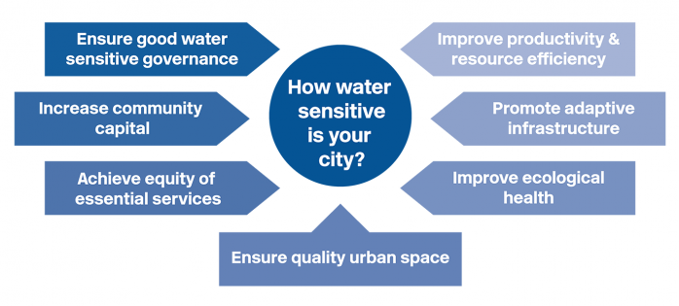Executive Summary

Introduction and background to place being benchmarked

Benchmarking was conducted through a collaborative, democratic process of voting from 1–5 against 34 primarily qualitative indicators grouped under 7 goals for water sensitivity as follows:

Figure 1: 7 Goals of A Water Sensitive City.

The benchmarking was conducted on insert date, in a full day workshop hosted by XXX. Participants included insert number representatives from insert organisation names. Each participant brought different technical and planning knowledge to help in information sharing and consensus development to rate the 34 indicators.

The benchmarking results are presented in the circular bar chart. This chart represents the stages of urban water management in a typical city, from a focus on (only) essential services (in the inner rings) through to delivery of a broader range of community outcomes (outer rings).

Insert summary of city–states results

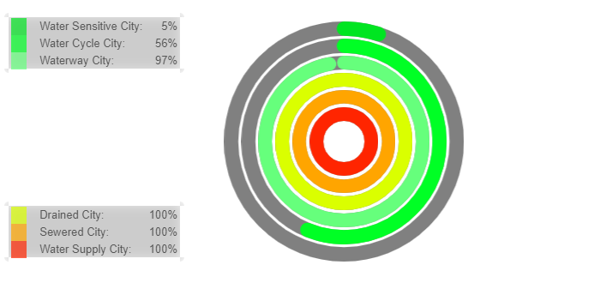

Figure 2: Benchmarking Results for XXXX.

Insert brief discussion of reasons for city–state results

Present scores for each goal area in the Water Sensitive Cities Index.

***Figure 3: Benchmarking results for each Goal Area.***

Opportunities for improvement are identified by considering the score for each goal area in the Index. These opportunities include:

* XXX
* XXX
* XXX
* XXX.

A XX-point action plan is provided based on the highlights from the benchmarking process. This aims to build on XXXX.

1. 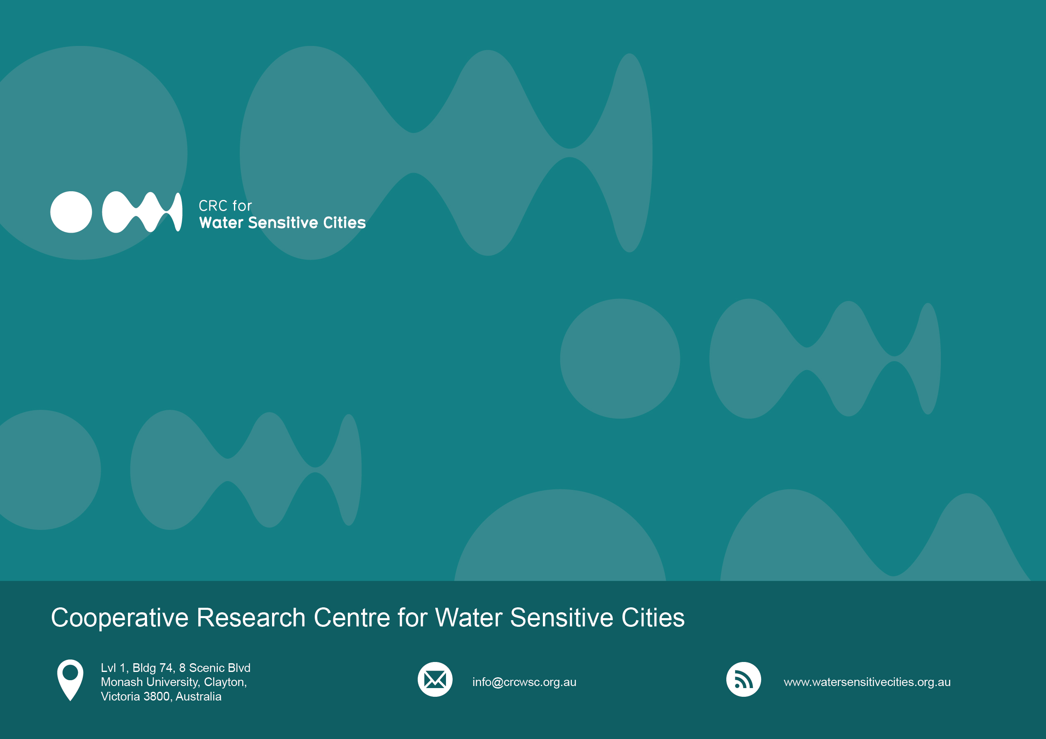Introduction

Water Sensitive Cities (WSC) are cities where water system services are optimised to enhance the liveability, sustainability, productivity and resilience of the city or town. Water sensitivity (also referred to as integrated water management) is characterised by multi-functional water infrastructure and urban design that operates as part of the water system. Citizens are involved in decision making and can participate in service delivery individually and collectively. Regional, centralised infrastructure is integrated with small scale, decentralised infrastructure.

The concept of a water sensitive city / integrated water management is increasingly being recognised as a means to support aspirations around liveability and community health and wellbeing. An example of this is the role of IWM in Victorian Government policy, such as *Water for Victoria* and the IWM Framework.

The Cooperative Research Centre for Water Sensitive Cities (CRCWSC) developed a standardised benchmarking methodology and tool to evaluate how cities are progressing against water sensitive city goals. This tool has been applied at a city scale across Australia and internationally.

This methodology is based on a collaborative and engaged process whereby input from a diverse range of stakeholders, who are instrumental in shaping our cities, can support facilitated discussion and qualitative appraisal against a suite of indicators relating to land use, infrastructure, natural environment and community understanding. This can then support an easily understood evaluation against a range of urban performance metrics to map areas of focus to improve on current activities.

The indicators relate to 7 goals:

* Ensure good water sensitive governance
* Increase community capital
* Achieve equity of essential services
* Improve productivity and resource efficiency
* Promote adaptive infrastructure
* Improve ecological health
* Ensure quality urban space.

For this project, the benchmarking process was applied to XXXX.

Description of location e.g. state, metropolitan/regional, coastal/inland, size, population, major land uses

Summary of water challenges e.g. strong population growth, climate change

Reason for benchmarking

This report sets out the benchmarking results as a baseline understanding for further planning by XXX.

1. WSC Index Tool

Many cities and towns face pressures of climate change, population growth and rising urbanisation. WSC recognise the fundamental importance of managing water resources and water systems services to enhance a city’s liveability, resilience, sustainability and productivity. Less clear is how an individual city or municipality can understand its current performance, and how water can contribute to these outcomes.

To address this gap, the CRCWSC developed the WSC Index, to help cities measure their performance and identify where they may improve their water sensitive practices. The Index is a functional, reliable and scientifically robust tool for benchmarking urban areas against 34 indicators that characterise a WSC. It has undergone 2 years of testing and validation with industry partners, supplying reliable evidence to use in seeking project funding or approval, and to track progress over time. It has also been applied in around 80 LGA and cities in Australia and internationally.

The WSC Index indicators relate to 7 goals:

***Figure 4:*** 7 Goals of A Water Sensitive City.

An accredited facilitator presents and explains the Index during workshops, bringing together experts, professionals and other interested groups. Workshop participants typically include representatives from councils, water authorities and state government agencies. The workshops allow participants to start developing the collaborative relationships necessary to bring about real change.

These workshops ensure participants think about WSC concepts and principles in the same way. Participants start by scoring the indicators individually, and then they discuss their scores, allowing participants to present their perspectives and question each other. All participants then agree on a final score for each indicator. The Index then translates these final scores into several measures of city status, to show the city’s progress towards greater water sensitivity. In this way, the Index helps participants identify what the city needs to improve.

The provider prepares a benchmarking and assessment report, which presents comprehensive results. This report also summarises the workshop discussions and the evidence supporting the ratings. The benchmarking results are also available on a web interface.

***Figure 5:*** 7 Goals And 34 Indicators of A Water Sensitive City.

* 1. Rating Process

Define the region

The Index was applied to XXX.

Engagement design

In the preparation of the rating process, the facilitators met with representatives of insert stakeholders to introduce the WSC indexing process and to plan the workshop. Plans were developed to ensure a broad range of teams from each organisation would attend the workshop.

Pre-scoring

To introduce the workshop to participants, and to initiate data collection for the project, a pre-scoring survey was distributed to stakeholders. A Survey Monkey form was sent to workshop participants with a request to rate each of the 34 indicators on a 1–5 scale and provide comments where appropriate to explain their rating. Participants could select the choice “Don’t know” if necessary. The pre-scoring results were used to guide workshop facilitation and the explanations identified in the pre-scoring have been combined with the workshop data to establish an evidence base for the indicator scores.

Workshop

A one-day workshop was held on XXX at XXXX. XXX participants from XXXX participated.

The workshop was structured around the 7 goal areas of the Index. Scoring of each goal area followed a similar process (see figure 6):

1. The facilitator explained the intent of the individual indicators
2. Open discussion and clarifications of the indicator and its scoring
3. Live polling through the Mentimeter platform
4. Review results and consensus reached among the group.

***Figure 6: The indicator scoring process.***

The XXXX indicators (Goal area X) were scored first, and as a single group. This provided a familiarisation exercise for the scoring process. Following this, participants were divided into 2 groups for the rest of the workshop. The first group considered the social and governance indictors, while the second group considered the bio-physical indicators.

* 1. Interpreting WSC Index Scores

The Index scores can be interpreted in several ways: against each of the goals and indicators, and through 3 diagnostic lenses. These lenses are summarised below and can be used to benchmark the water related outcomes between future years, other comparable cities (internationally) or aspirations to improve IWM outcomes.

**Water Sensitive City Goals**

This presents the results in terms of strengths and weaknesses against each of the 7 goals. Each goal is assessed on a score out of 5 based on an average of the contributing indicators, with 5 representing outcomes which fully support a water sensitive city.

City–state Benchmarking

City–state benchmarking maps the percentage attainment for progress against each of the city states in the Urban Water Transitions Framework continuum, being:

* Water Supply City
* Sewered City
* Drained City
* Waterway City
* Water Cycle City
* Water Sensitive City.

This is not presented in a linear fashion as a city can achieve multiple city states at the same time. These results are presented as both percentages attained against individual city states and as circular bar plot.

The Urban Water Transitions Framework is further explained in Appendix A.

Water Sensitive Outcomes

This lens assesses the city against the 4 outcomes of a water sensitive city: liveability, sustainability, productivity and resilience.

Resilience in this context is defined as the capacity to maintain water system services under acute or chronic disturbances, through adaptation or recovery. Sustainability is the capacity of water system services to deliver benefits for current and future generations. Liveability is the capacity of the water system to deliver a high quality of life for communities (such as thermal comfort, aesthetics, amenity, connection to place, etc.). Productivity is the capacity of the water system services to generate economic value.

Outcomes are scored out of 5, with scores based on average workshop scores of the indicators which most influence each outcome. Individual indicator ratings can contribute to multiple WSC outcomes. For example, improving the rating for the indicator ‘diversify self-sufficient fit-for-purpose water supply’ related to provision of alternative water supplies would improve both resilience and sustainability outcomes.

Water Sensitive Practices

The final lens looks at the 3 pillars essential to delivering water sensitive services, and scores these out of 5. The pillars are:

* **Cities as water supply catchments** – An urban area serves as a potential water supply catchment, providing a range of different water sources at a range of different scales, and for a range of different uses.
* **Cities providing ecological services** – A city or town provides ecosystem services and a healthy natural environment, thereby offering a range of social, ecological and economic benefits.
* **Water Sensitive Communities** – Cities and towns have water sensitive communities where citizens have the knowledge and desire to make wise choices about water, are actively engaged in decision making and demonstrate positive behaviours

1. Evaluating Performance
   1. City–State Benchmarking

The benchmark results for XXX are shown in figure 7. Percentage attainment varied from XX% as a XXX to XX% as a Water Sensitive City. This section summarises the key elements that contribute to the overall percentage attainment of each city–state.

***Figure 7:*** Benchmarking Results for XXX.

**XX% attainment of Water Supply City, Sewered City and Drained City states**

Urban water management in XXX …

**XX% attainment of Waterway City state**

XXX rated XX% as a Waterway City reflecting …

**XX% attainment of Water Cycle City state**

Urban water management in XX is rated XX% as a Water Cycle City. This reflects …

**XX% attainment of Water Sensitive City state**

XXX rated 5% as a Water Sensitive City.

* 1. Water Sensitive Goals

The Index summarises the performance of XXXX against the 7 goals of a Water Sensitive City (figure 8). Appendix B also provides a comparison of these scores with a range of other cities and towns.

As shown in figure 8, XXX’s key strengths are:

* XXXX
* XXXX
* XXXX.

This reflects …

As with other cities, a number of goal areas have room for improvement …

Establishing a thriving WSC also requires …

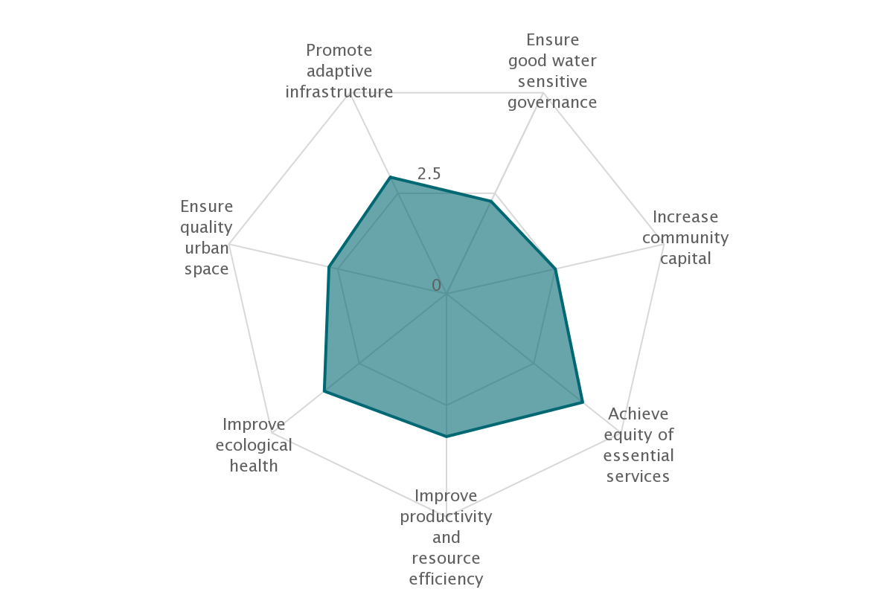

***Figure 8: Goal area*** results for XXXX.

In XXX, the goal areas to be further strengthened are:

* XXXX
* XXXX
* XXXX.

These opportunities are further explained below.

**Ensuring good water sensitive governance**

Indicator 1.1 Knowledge, skills and organisational capacity

*Current status*:

Indicator 1.2 Water is key element in city planning and design

*Current status*:

Indicator 1.3 Cross-sector institutional arrangements and processes

*Current status*:

Indicator 1.4 Public engagement, participation and transparency

*Current status*:

Indicator 1.5 Leadership, long-term vision and commitment

*Current status*:

Indicator 1.6 Water resourcing and funding to deliver broad societal value

*Current status*:

Indicator 1.7 Equitable representation of perspectives

*Current status*:

Increase community capital

Indicator 2.1 Water literacy

*Current status*:

Indicator 2.2 Connection with water

*Current status*:

Indicator 2.3 Shared ownership, management and responsibility of water assets

*Current status*:

Indicator 2.4 Community preparedness and response to extreme events

*Current status*:

Indicator 2.5 Indigenous involvement in water planning

*Current status*:

Achieve equity of essential services

Indicator 3.1 Equitable access to safe and secure water supply

*Current status*:

Indicator 3.2 Equitable access to safe and reliable sanitation

*Current status*:

Indicator 3.3 Equitable access to flood protection

*Current status*:

Indicator 3.4 Equitable and affordable access to amenity values of water-related assets

*Current status*:

Improve productivity and resource efficiency

Indicator 4.1 Benefits across other sectors because of water-related services

*Current status*:

Indicator 4.2 Low GHG emissions in water sector

*Current status*:

Indicator 4.3 Low end-user potable water demand

*Current status*:

Indicator 4.4 Water-related commercial and economic opportunities

*Current status*:

Indicator 4.5 Maximised resource recovery

*Current status*:

Improve ecological health

Indicator 5.1 Healthy and biodiverse habitat

*Current status*:

Indicator 5.2 Surface water quality and flows

*Current status*:

Indicator 5.3 Groundwater quality and replenishment

*Current status*:

Indicator 5.4 Protect existing areas of high ecological value

*Current status*:

Ensure good quality urban spaces

Indicator 6.1 Urban elements functioning as part of the urban water system

*Current status*:

Indicator 6.2 Urban elements functioning as part of the urban water system

*Current status*:

Indicator 6.3 Vegetation coverage

*Current status*.

**Promote adaptive infrastructure**

Indicator 7.1 Diversify self-sufficient fit-for-purpose water supply

*Current status.*

Indicator 7.2 Multi-functional water infrastructure system

*Current status*.

Indicator 7.3 Integration and intelligent control

*Current status*.

Indicator 7.4 Robust infrastructures

*Current status*:

Indicator 7.5 Infrastructure and ownership at multiple scales

*Current status*:

Indicator 7.6 Adequate maintenance

*Current status*:

Water sensitive outcomes and practices

The WSC Index filters results based on WSC outcomes and practices. These are discussed in the following sections.

WSC outcomes

Water sensitive outcomes assesses the performance of the urban water system against the delivery of Resilience, Sustainability, Liveability and Productivity outcomes, as described in section 2.2.

The results infigure 9indicate how XXXX is performing across the WSC outcomes on a 1–5 scale.

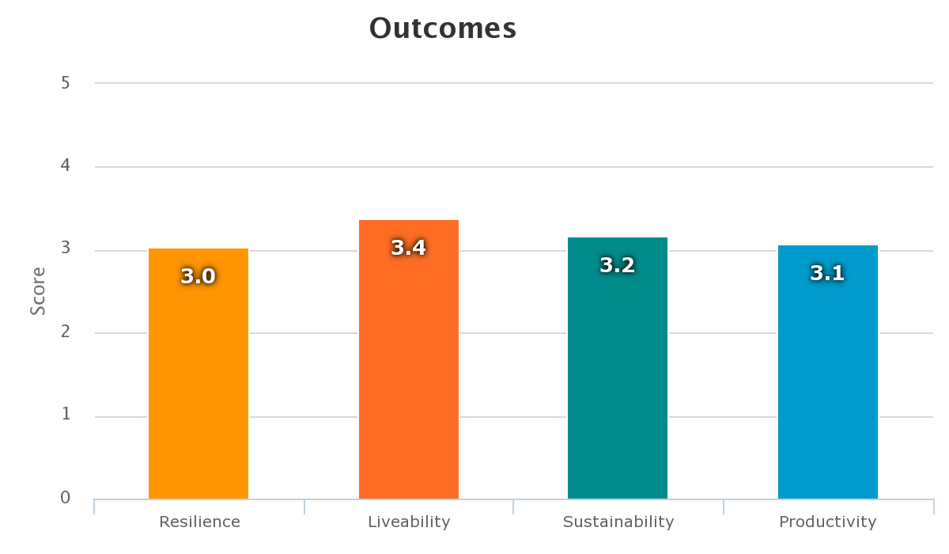

***Figure 9:* *Assessment of Water Sensitive Outcomes.***

**WSC practices**

The results in figure 10 indicate how XXX is performing with regard to WSC practices.

*****Figure 10: Assessment of Water Sensitive Practices.*****

1. A X-Point Plan

An action plan has been developed for XXXX summarising some of the key highlights from the benchmarking process. Actions are listed under the 3 transition pathways identified in figure 11, and do not reflect the priority of actions to be undertaken. Actions are mutually reinforcing and provide an overarching framework for consideration by XXXX and to guide progress towards the aspirations of a water sensitive city.

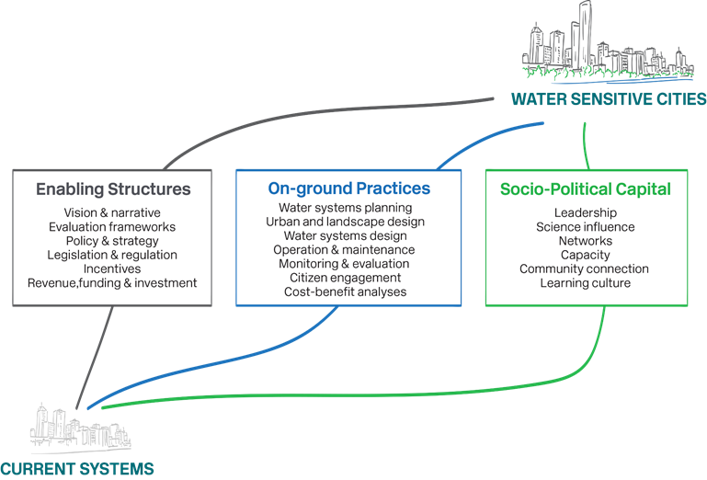***Figure 11:* *Transition Pathways to Improve Water Sensitive Practices and Deliver Water Sensitive Outcomes.***

* 1. Enabling Structures

**Action X: XXX**

* 1. On-ground Practices

**Action X: XXX**

* 1. Socio-Political Capital

**Action X: XXX**

Appendix A: The Urban Water Transitions Framework

*The following is adapted from Brown et al 2016*

The Urban Water Transitions Framework (Brown et al., 2009) identifies 6 developmental states that cities move through on their path towards increased water sensitivity. It can help urban water strategists define the attributes of more sustainable cities and identify the capacity needs and institutional changes required for more sustainable water management. Figure 12 presents the Urban Water Transitions Framework.

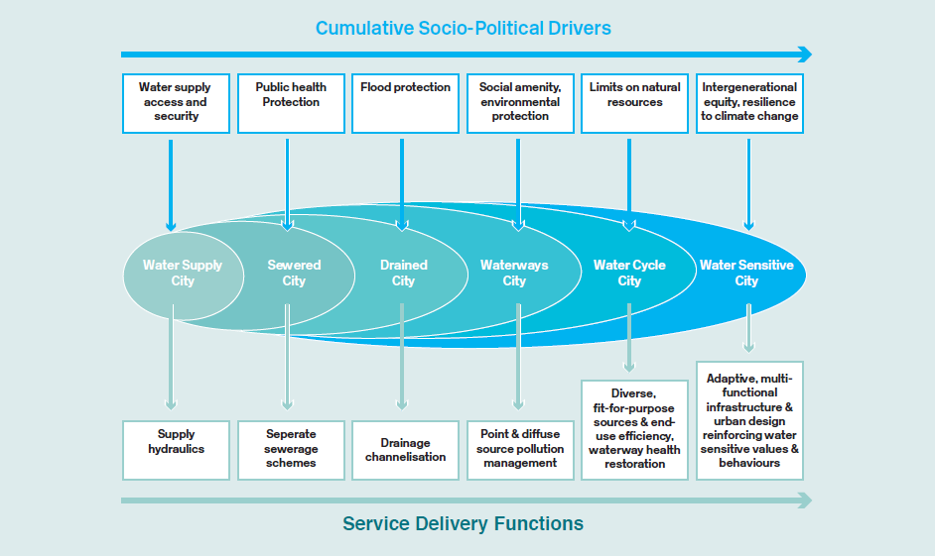

***Figure 12: The Urban Water Transition Framework (Brown et al, 2009).***

The 6 states form a continuum that can be mapped along 2 dimensions:

* Socio-Political Drivers: the demands and expectations that emerge from society’s growing environmental awareness, amenity expectations and evolving attitudes toward water management
* Service Delivery Functions: the increasingly diverse services required to address those drivers as cities transition to greater sustainability.

The first 3 states of water management meet largely utilitarian expectations of supplying water, protecting public health and mitigating the impacts of floods. However, the following 3 states mark a significant shift beyond survival needs, towards a more sophisticated goal of greater water self-sufficiency and reduced environmental impact. Rivers, streams and lakes are now seen as places for social interaction and aesthetic appreciation; communities are becoming increasingly proud of their sustainable water management practices. Innovative design solutions tailored to local contexts become dominant features in cities in the later transition states. Importantly, the framework reflects an embedded continuum, whereby later city–states build on infrastructure and approaches achieved in earlier city–states.

Three pillars of a water sensitive city

The continuum underpinning the Urban Water Transitions Framework is built on 3 principles (or ‘pillars’) of practice:

1. Cities as water supply catchments
2. Cities providing ecosystem services
3. Cities comprising water sensitive communities.

The **first pillar** represents the concept of cities not relying exclusively on their natural water sources – be that rainfall runoff accumulated in catchments or groundwater. Instead, they should develop a broader portfolio of water sources, including urban stormwater, roof runoff, recycled wastewater, desalinated water and groundwater. In a Water Sensitive City, these sources would be utilised as required through a variety of infrastructures associated with water harvesting, storage, treatment and delivery.

The **second pillar** envisions an urban landscape that actively supports the environment, rather than degrading it and draining it of resources. This can be achieved through innovative use of public spaces and green spaces. In addition to providing public amenities, these spaces could incorporate sustainable water management alongside other ecological services such as carbon sinks, opportunities for food production, and an improved micro-climate through providing shade.

The **third pillar** points to the importance of institutional capacity and social support for achieving sustainable urban water management. To successfully implement this pillar, the local institutions invested in and responsible for delivering water management must fully embrace technological solutions. It also requires a community to be informed and engaged about water, and actively involved in the co-management of water services.

References

Brown, R.R., Keath, N., & Wong, T.H.F. (2009). Urban water management in cities: Historical, current and future regimes. Water, Science and Technology: A Journal of the International Association on Water Pollution Research, 59(5), 847–55.

Brown, R., Rogers, B., Werbeloff, L. (2016). Moving toward Water Sensitive Cities: A guidance manual for strategists and policy makers. Melbourne, Australia: Cooperative Research Centre for Water Sensitive Cities.

Wong, T.H.F., & Brown, R.R. (2009). The Water Sensitive City: Principles for practice. Water, Science and Technology: A Journal of the International Association on Water Pollution Research, 60(3), 673–82.

Appendix B: Comparision of results with other cities and towns

The following chart shows how XXXX scored compared with other cities and towns. The charts show the scores for each Goal area, and the overall benchmark score. Comparisons are made with major metropolitan cities, regional cities in other states, other regional cities in Victoria and other LGAs in Melbourne.

The value of this comparison lies in identifying similar cities and towns with whom IWM strategies can be shared for mutual gain.

Appendix C: Workshop Notes

| **Indicator** | **Rating**  **0–5** | **Confidence**  **High/Med/Low** | **Evidence** |
| --- | --- | --- | --- |
| **1. Ensure good water sensitive governance** | | | |
| 1.1. Knowledge, skills and organisational capacity |  |  |  |
| 1.2. Water is key element in city planning and design |  |  |  |
| 1.3. Cross-sector institutional arrangements and processes |  |  |  |
| 1.4. Public engagement, participation and transparency |  |  |  |
| 1.5. Leadership, long-term vision and commitment |  |  |  |
| 1.6. Water resourcing and funding to deliver broad societal value |  |  |  |
| 1.7. Equitable representation of perspectives |  |  |  |
| **2. Increase community capital** | | | |
| 2.1. Water literacy |  |  |  |
| 2.2. Connection with water |  |  |  |
| 2.3. Shared ownership, management and responsibility of water assets |  |  |  |
| 2.4. Community preparedness and response to extreme events |  |  |  |
| 2.5. Indigenous involvement in water planning |  |  |  |
| **3. Achieve equity of essential services** | | | |
| 3.1. Equitable access to safe and secure water supply |  |  |  |
| 3.2. Equitable access to safe and reliable sanitation |  |  |  |
| 3.3. Equitable access to flood protection |  |  |  |
| 3.4. Equitable and affordable access to amenity values of water-related assets |  |  |  |
| **4. Improve productivity and resource efficiency** | | | |
| 4.1. Benefits across other sectors because of water-related services |  |  |  |
| 4.2. Low GHG emission in water sector |  |  |  |
| 4.3. Low end-user potable water demand |  |  |  |
| 4.4. Water-related business opportunities |  |  |  |
| 4.5. Maximised resource recovery |  |  |  |
| **5. Improve ecological health** | | | |
| 5.1. Healthy and biodiverse habitat |  |  |  |
| 5.2. Surface water quality and flows |  |  |  |
| 5.3. Groundwater quality and replenishment |  |  |  |
| 5.4. Protect existing areas of high ecological value |  |  |  |
| **6. Ensure quality urban space** | | | |
| 6.1. Activating connected pleasant urban green and blue space |  |  |  |
| 6.2. Urban elements functioning as part of the urban water system |  |  |  |
| 6.3. Vegetation coverage |  |  |  |
| **7. Promote adaptive infrastructure** | | | |
| 7.1. Diversify self-sufficient fit-for-purpose water supply |  |  |  |
| 7.2. Multi-functional water infrastructure system |  |  |  |
| 7.3. Integration and intelligent control |  |  |  |
| 7.4. Robust infrastructures |  |  |  |
| 7.5. Infrastructure and ownership at multiple scales |  |  |  |
| 7.6. Adequate maintenance |  |  |  |

